Please check below image for Admin Panel:

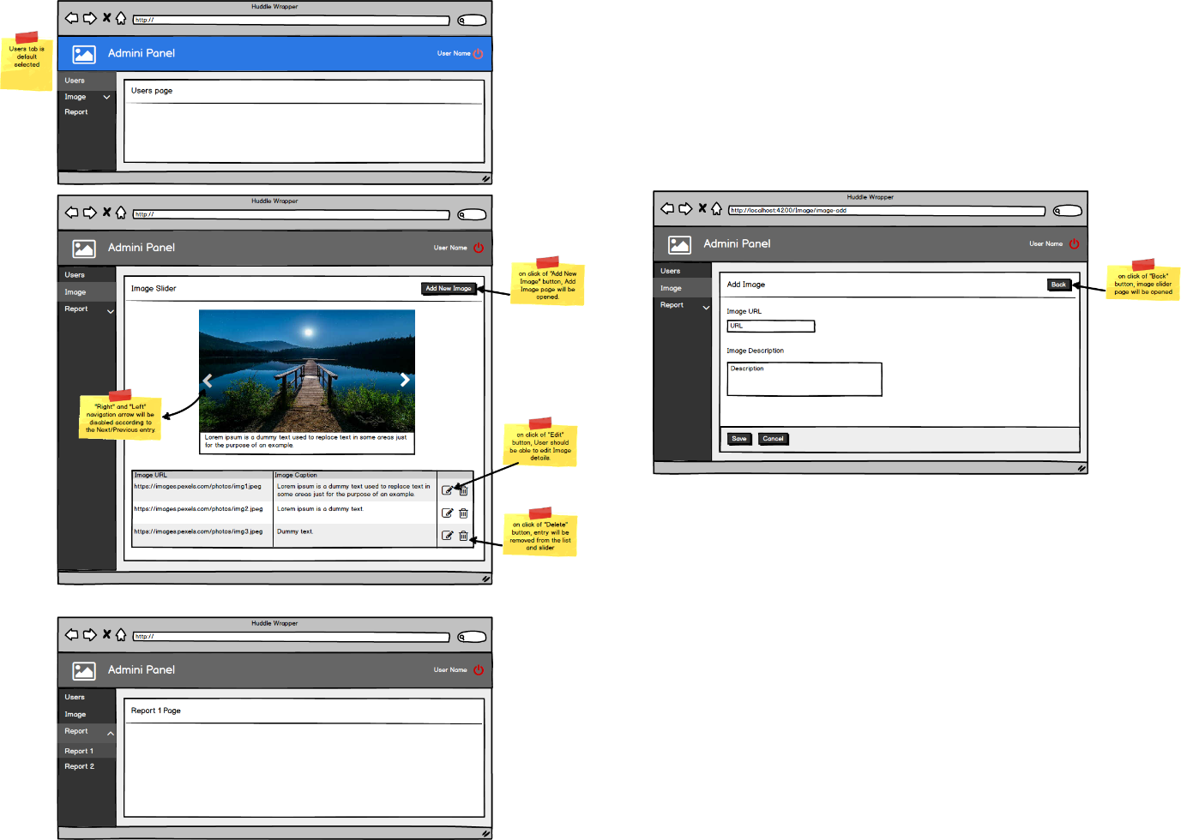

**Description:**

Design one admin panel, in which there are three menu options Users, Image, Report in the sidebar. There should be two sub-options – Report 1, Report 2 of Report menu option. When any sub-option is selected then its parent option should be active. Set color for hover menu options. Set a proper route and page for each menu option.

In the Image page, one image slider and “Add Image” button is there. In the image slider, added image detail and “Next/Previous” arrow should be displayed. Arrows should be disabled based on next/previous list data. On click of “Add Image” button Add Image page should be open, in which a user should be able to add an image URL and caption/description for the image.

All added image URL and caption/description should be displayed in the table and image slider. From the table, a user should be able to edit image details.

**Note:** You have to develop a demo using Angular, SCSS, HTML. The demo should be in proper color combinations and fully responsive for all the devices.